##### ~~Qu~~ IN&BETWEEN

1. Listthetypeofthecourses“Statistics”and“Programming”
2. Theinstructorwants toknowtheCourseNos whosescoresareintherange50to80

##### AGGREGATE

1. Findtheaveragemarkof“C002”.
2. Listthe maximum,minimummarkfor“C021”
3. Listthe maximum,minimum,averagemarkforeachsubjectin5thsemester
4. Listthenameofthecourses andaveragemarkofeachcourses.
5. Calculatethesumofallthescores.
6. Howmanystudentsareregisteredforeachcourse?Displaythecoursedescriptionandthenumberofstudents registeredineachcourse.

Howmanycoursesdideachstudentregisterfor? UseAssessmenttable

OUTPUTS:

1)

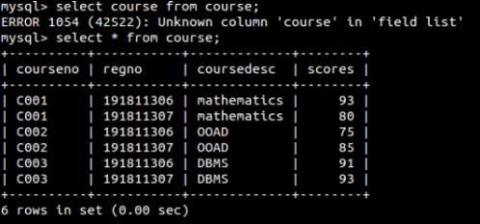

2)

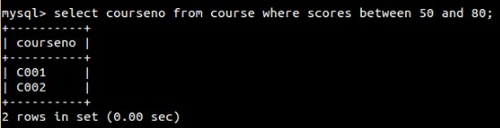

1)

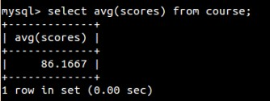

2)

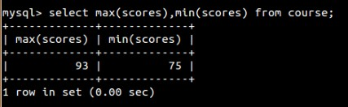

3)

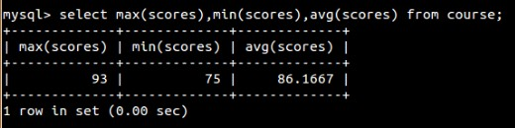

4)

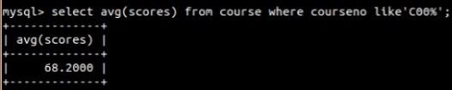

5)

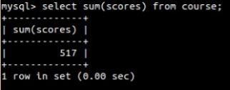

6)

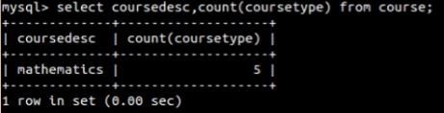

7)

